TASK DIGITAL SKOLA
Nama: Janji Nur Subekti

Requirement Software
NO | NAMA | Keterangan | Gambar
1 | Java |  | 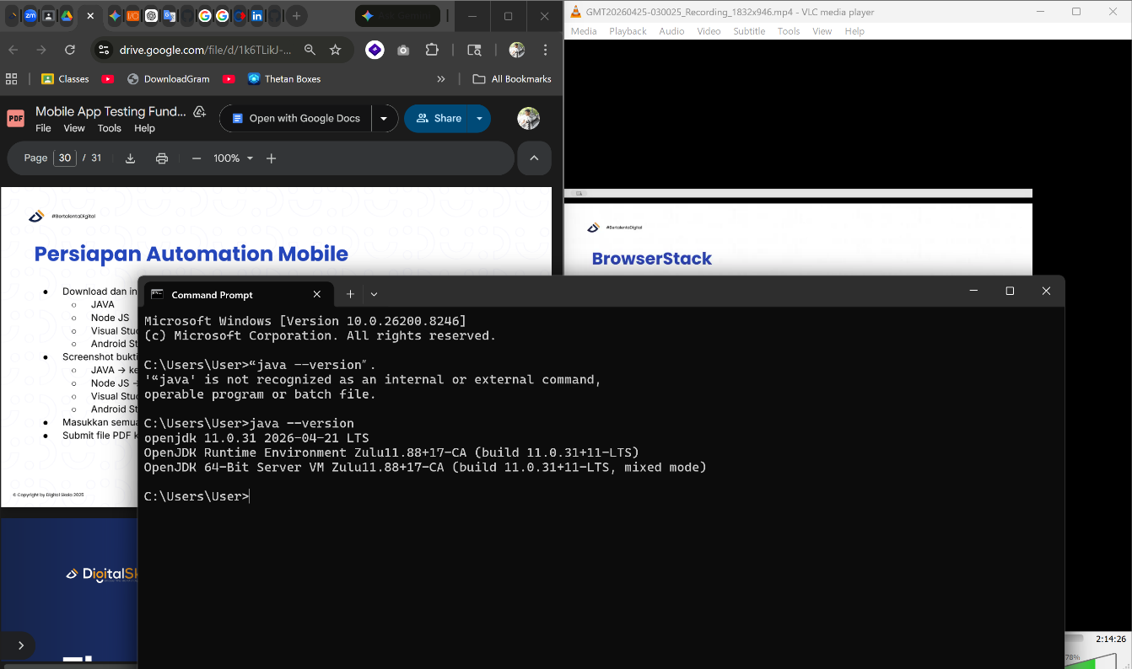
2 | NODE JS |  | 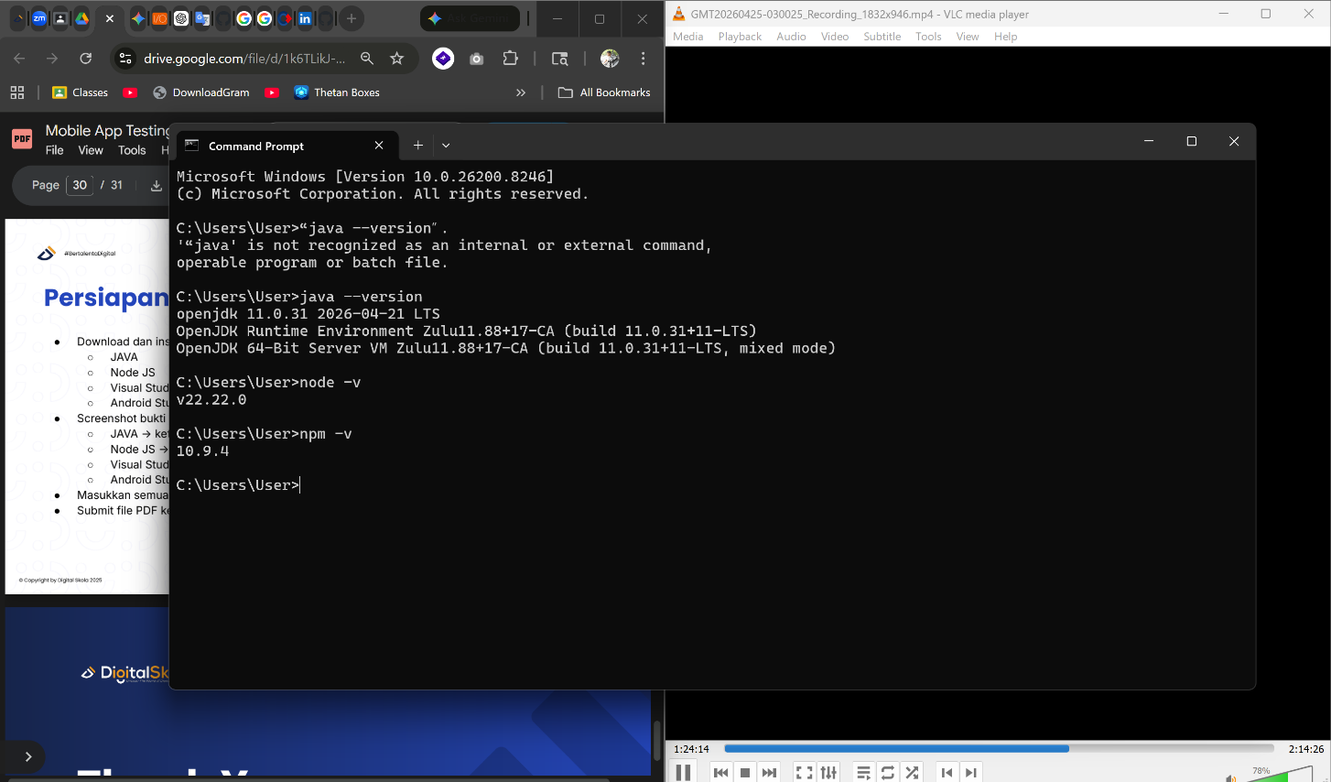
3 | VsCode |  | 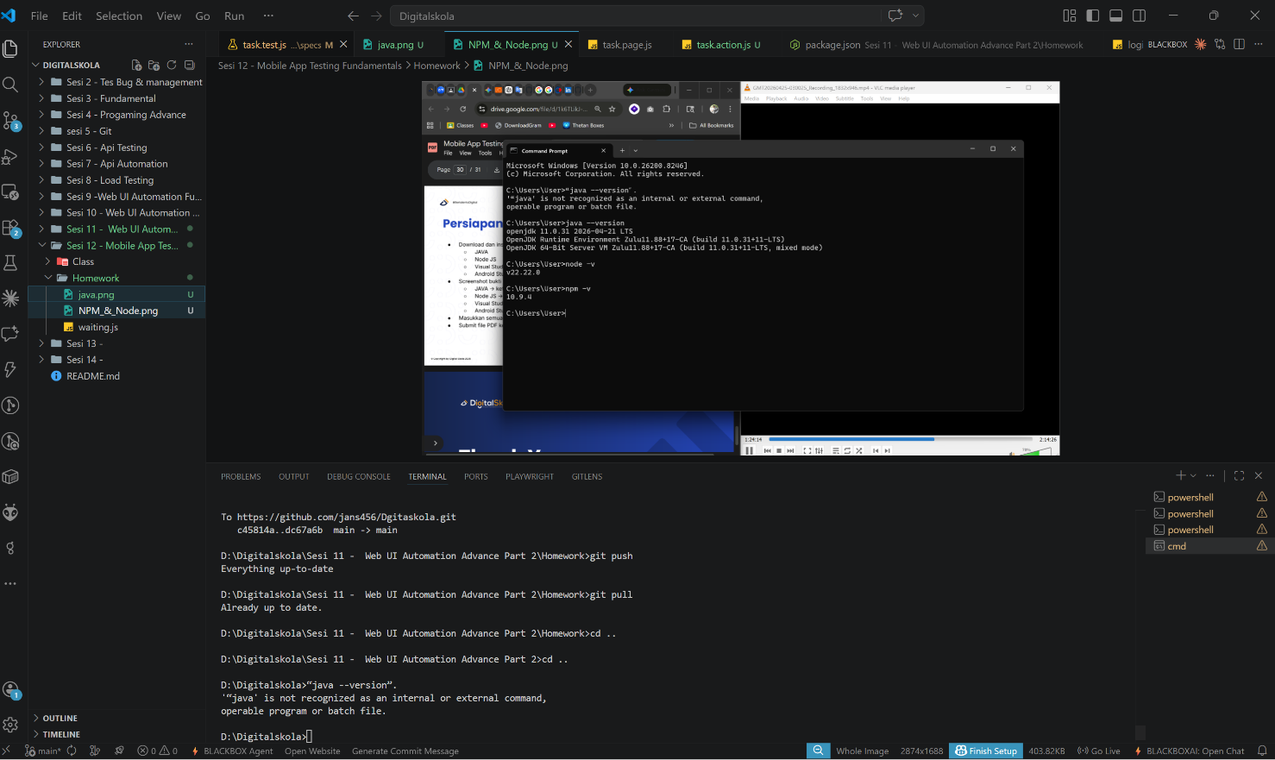
4 | AndroidStudio |  | 